**IS 306 Data Management Communications and Networking**

**HOP01B – Installing MySQL using Docker**

12/27/2019 Developed by Clark Ngo

Center for Information Assurance (CIAE) @City University of Seattle (CityU)

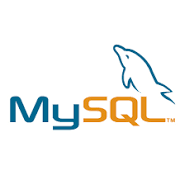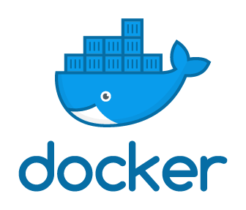

**Before You Start**

* Version numbers may not match with the most current version at the time of writing. If given the option to choose between stable release (long-term support) or most recent, please choose the stable release rather than beta-testing version.
* This tutorial targets Windows users and MacOS users.
* There might be subtle discrepancies along the steps. Please use your best judgement while going through this cookbook style tutorial to complete each step.
* For your working directory, use your course number. This tutorial may use a different course number as an example.
* The directory path shown in screenshots may be different from yours.
* If you are not sure what to do or confused with any steps:
  1. Consult the resources listed below.
  2. If you cannot solve the problem after a few tries, ask a TA for help.

**Learning Outcomes**

Students will be able to:

* Installing MySQL using Docker

**Resources**

* Docker - <https://www.docker.com/>
* Docker Documentation - <https://docs.docker.com/>
* Docker Hub - <https://hub.docker.com/>
* MySQL - <https://www.mysql.com/>
* MySQL Documentation - <https://dev.mysql.com/doc/>

**MySQL:**

**Run your Docker Application**

1. Find the Docker App and double-click

**Run an instance of MySQL through docker**

1. Open your terminal / command prompt and type the following:

docker run --name mysql_instance -p 3307:3306 -e MYSQL_ROOT_PASSWORD=passwd -d mysql:5

Example output in MacOS:



Note: if it can’t connect, start the docker container again with

docker container start mysql_instance

**Run an MySQL interactive shell**

1. Open your terminal / command prompt and type the following:

mysql -h 127.0.0.1 -P 3307 -p -u root

When prompted for password: *passwd*

Example output in MacOS:

